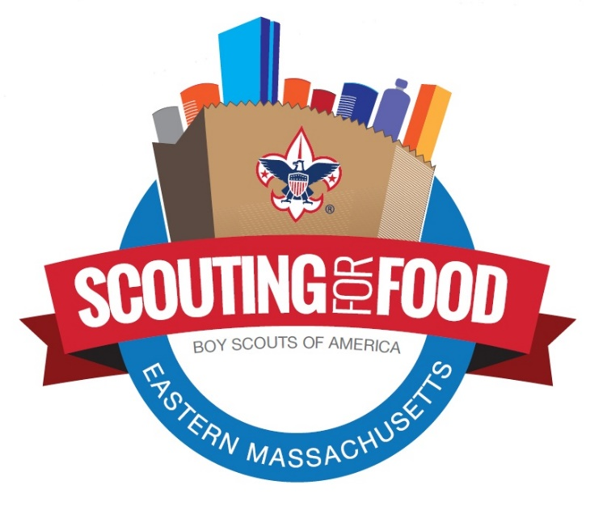

Hunger, it’s a way of life for an increasing number of families, especially during these times. Many face hopeless decisions around paying for medicine, heat, or food. With kids in virtual classrooms, access to subsidized meals has become a widespread issue. Groups providing assistance struggle with increasing requests and shrinking resources. The Boy Scouts of America answer this call by collecting food and supporting community agencies that fight hunger.

Help us provide food and hope to our neighbors

Use this space to provide your unit information and collection plan (dates, times, location, specific contactless collection process)

**Canned Goods, Peanut Butter, Cereal, Pancake or Muffin Mix, Crackers or Cookies, Instant Soup, Rice or Beans, Pasta, Powdered Juice or Milk, Dried Fruits, Snack Bars, Adult or Infant Diapers, or Single-Serve Non-Frozen Dinners.**

Any other non-perishable food items.

Please do not include frozen foods, glass jars, open containers, or expired items.

**Suggested Items:**