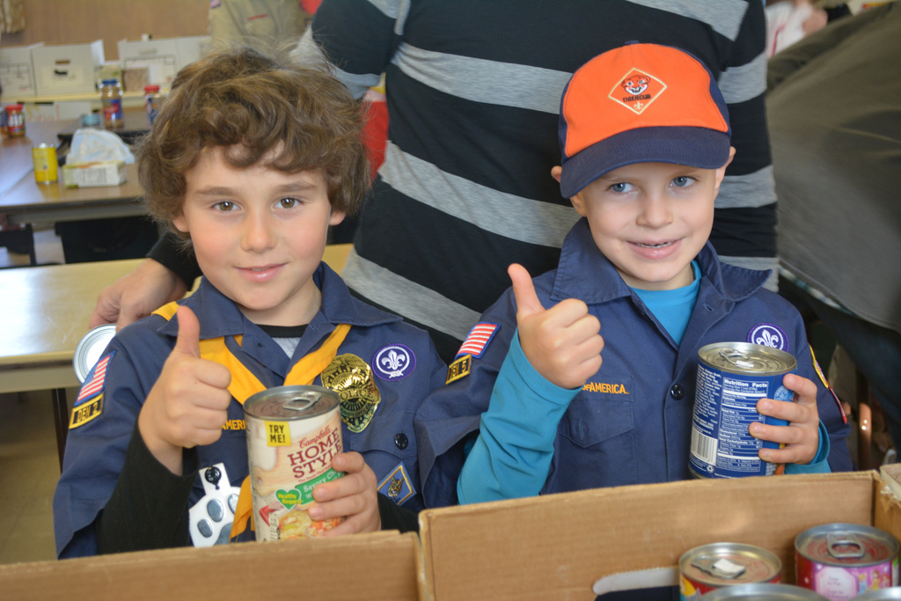  Oct 28 & Nov 4, 2017  Scouting for food  Be a part of the largest single day Good Turn all year!  The Scouting for Food Good Turn is a massive food collection effort by over 10,000 youth and their leaders in the 62 communities in our council. Council 251 will join hands with local businesses and media in a massive community food collection good turn.  The Scouting for Food campaign will involve a door-to-door food collection effort by Scouts. On the first of two successive Saturdays, Scouts will distribute information door hangers throughout their designated area. The following Saturday the bags of food are to be collected and taken to local food pantries.  Join us at the 2017 Scouting For Food kick-off on Monday, June 12th at the Fay School, Southborough, MA.  Come and hear about all the exciting things in store for this year’s campaign and receive all the materials you will need to have a successful Scouting for Food Drive in your community and enjoy some light refreshments.  Visit  www.ktc-bsa.org/event/sff-kickoff  for Additional Details and to Register  Council Two Fifty One, BSA 2 Mt. Royal Ave – Suite 100, Marlborough, MA 01752 – 508.872.6551 |  | Feed the Hungry Locally  -----------  Community Service  -----------  Scouts Helping Others  -----------  Tools for success in your community  Cam  Fay School  Southborough, Massachusetts  Kick-Off Meeting  Monday, June 12th  7pm

