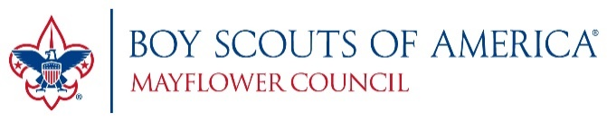
Boy Scouts of America – Mayflower Council
<<Name>> - Committee Chair
<<Unit Name>>
<<City, State>>
<<Phone Number>>
<<date>>
Dear <<Manager Name>>,
I am writing to you on behalf <<Unit Name>> of the Mayflower Council, Boy Scouts of America. I am currently planning our annual popcorn fundraiser, which begins <<start date>> and concludes on <<end date>>.
Our popcorn fundraiser is extremely important to Boy Scouts of America as it generates the financial support our council, and our individual units, need to maintain our program and provide services in the community. Store-front sales are key to the success of this important fundraiser. <<We appreciate your support in previous years and hope you will welcome us back again this year.>>
<<Unit Name>> is requesting permission to fundraise at your store on the weekends starting <<start date>> and ending on <<end date>>. We typically sell on Friday evening, and throughout the day on Saturday and Sunday. We would like to setup a table outside one door, or multiple doors if that is acceptable. We will ensure we do not interfere with the flow of your customer traffic, and we will leave our area and the front of the store cleaner than when we found it.
I look forward to your response via email or phone.
Thank you,
<<Your Name>>
Committee Chair
<<Unit Name>>
Cell: <<phone number>>
<<email address>>

