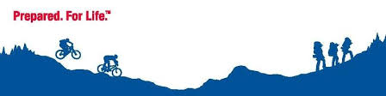

### Cubmaster

Ken Sarnie

ken.sarnie55@comcast.net

### Committee Chair

Krista Felaco

[kfelaco@gmail.com](mailto:kfelaco@gmail.com)

### Contact Info

www.pack100.net

www.beascout.org

# *Pack 100 Bellingham Cub Scouts*

Scout Name: ___________________________

Parent Name: __________________________

Address: ______________________________

Email: ________________________________

Phone: _______________________________

Pack #: ___________ Den #: __________

***Summertime Passport To Fun 2014***

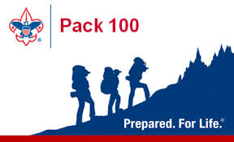

|  |  |  |
| --- | --- | --- |
|  |  |  |

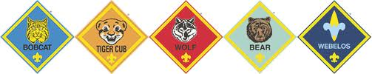

Welcome to a great summer adventure of being a Scout parent! As a Cub Scout, your child will have the opportunity to grow, learn and have fun doing Cub Scout activities. The Super Summer Passport program was designed to give you, your Cub Scout and your family an idea of the Cub Scouting program! We are aware that the current economy may create challenges for some households. With that in mind, we have tried to create a program that may be accomplished with little to no cost. To earn the Summertime Pack Award, you and your Scout may choose and complete any 6 of the suggested summertime activities and log them into your Summer Passport. Be sure to turn in your Scout’s passport at the September Registration night on Friday, Sept 12 for your scout, and your Scout will receive the Summertime Pack Award at the Sept. Pack Meeting! Visit www.pack100.net to check our calendar for updates so your Scout doesn’t miss out on any adventures!

**Summertime Award = 6 Activities**

**Super Cub = 12 Activities**

**Super-Duper Cub = 16 Activities**

**Extreme Cub = 24 Activities**

**# Activities Completed: __________**

**Please check off each activity completed and fill in date of activity:**

* ____1 Went swimming at a lake or ocean
* ____2 Attended a Summer Pack Event
* ____3 Attended Cub Day Camp/other Camp
* ____4 Went to a sporting event
* ____5 Bellingham 4th of July fireworks
* ____6 Mendon Drive-In
* ____7 Concert on the Common
* ____8 Blackstone Valley bike ride (August 17th)/other
* ____9 Had a Family Picnic
* ____10 Visited a County, State, or Town Fair
* ____11 Visited a public library
* ____12 Visited a MA state park
* ____13 Visited an airport or train station
* ____14 Took a ride on public transportation
* ____15 Visited a science center/museum
* ____16 Went fishing
* ____17 Visited a zoo
* ____18 Visited an aquarium
* ____19 Patriots Training Camp
* ____20 Visited a ntn’l monument/historical site
* ____21 Participated in Memorial Day Parade
* ____22 Recruit a friend to join Cub Scouts
* ____23 Go geocaching/letterboxing
* ____24 Visited the public library
* ____25 Go to a Paw Sox game
* ____26 Reviewed next rank in Cub Scout handbook
* ____27 Visited an art museum
* ____28 Took a hike on hiking trails
* ____29 Visited a workplace
* ____30 Made and shared a family snack
* ____31 Read 30 minutes with a parent
* ____32 Attended Chuck Wagon (June 2nd)
* ____33 Marched in Memorial Day Parade (May 18th)
* ____34 Attended Annual Camporee (June 21st)
* ____35 Participated in Flag Day in uniform (June 13th)